MIZAN English demonstration script

MIZAN PRESENTATION
Financial workflows

English · REVIEW
Bank, settlement, KYT, LP, FX and quote sources are MOCK or synthetic. Product AI is DISABLED.
Press Play to begin.
Captions are optional.

Presentation preparation and browser use
1. Press Play to begin. Narration follows each scene and moves to the next scene automatically.
2. Previous and Next change the scene. Pause stops the narration and Play resumes it.
3. Presenter settings contains the scene list, presentation route and complete script. Close the panel for the audience view.
4. The entire saved screen fits inside the viewing area. Captions are optional. Fullscreen provides a larger viewing area.

Contents (1–14)
01. MIZAN financial operations · 8
02. Roles and responsibilities · 8
03. Transaction states · 8
04. Following a transaction · 8
05. Approval conditions and residuals · 8
06. Journal and reserved funds · 8
07. Transaction evidence · 8
08. LP debt after payout · 8
09. Comparing route costs · 8
10. Quoted and observed costs · 8
11. Cost adjustment approval · 8
12. Daily close and open items · 8
13. Settlement calendar · 8
14. Fixed transaction schedules · 8

Contents (15–28)
15. LP agreements and period costs · 8
16. Configuration approval · 8
17. Preparing a workflow · 8
18. Period and customer limits · 8
19. Bank responses and replay · 8
20. Request approval and execution · 8
21. Compliance and risk holds · 8
22. Personal customer scope · 8
23. Business customer scope · 8
24. AI usage policy · 8
25. Evidence and report drafts · 8
26. Recovering an unconfirmed transaction · 8
27. Accounts and access · 8
28. Workflow summary · 8

Diagram 1
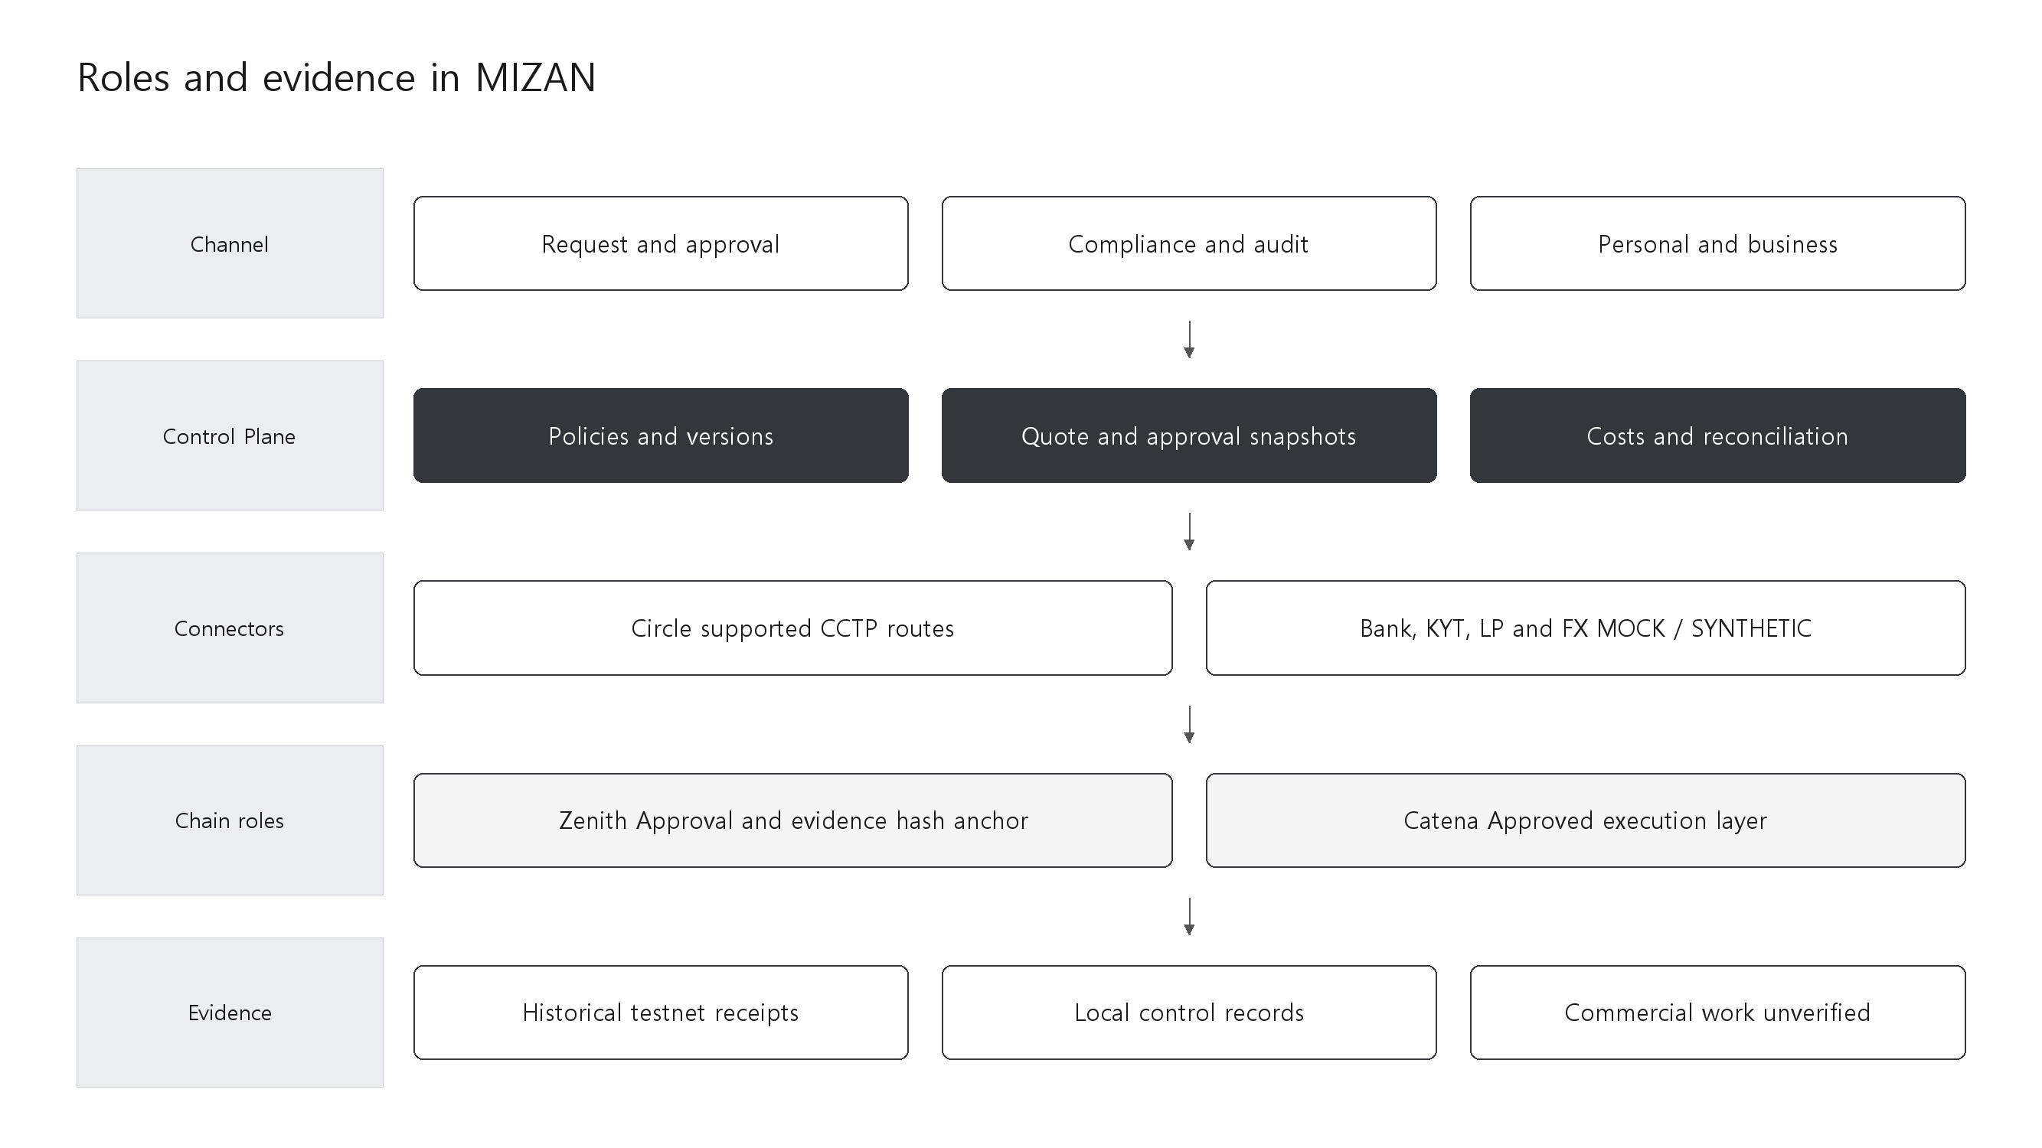
Editable diagrams
Zenith anchors approval, policy and evidence hashes. Catena executes approved work and is not an official Circle CCTP domain. Connector logos do not establish external integration success.

Diagram 2
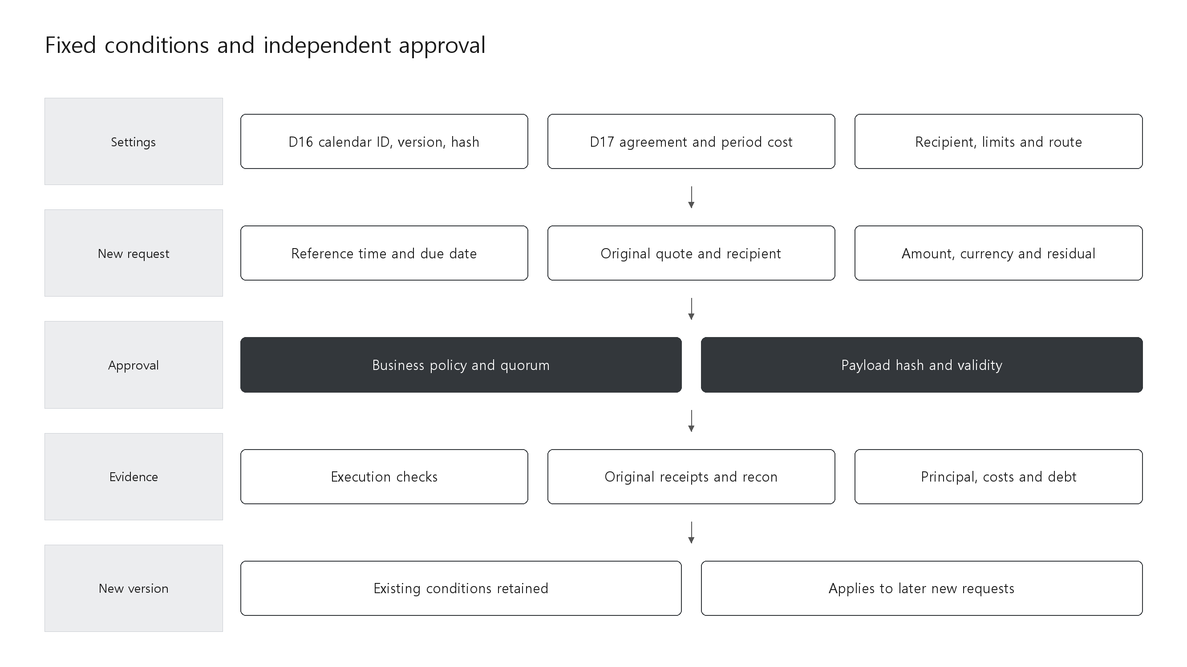
Editable diagrams
New quotes and approvals fix original conditions and applicable versions. Configuration changes apply to subsequent requests. Existing transactions retain their original reference and approval versions.

Diagram 3
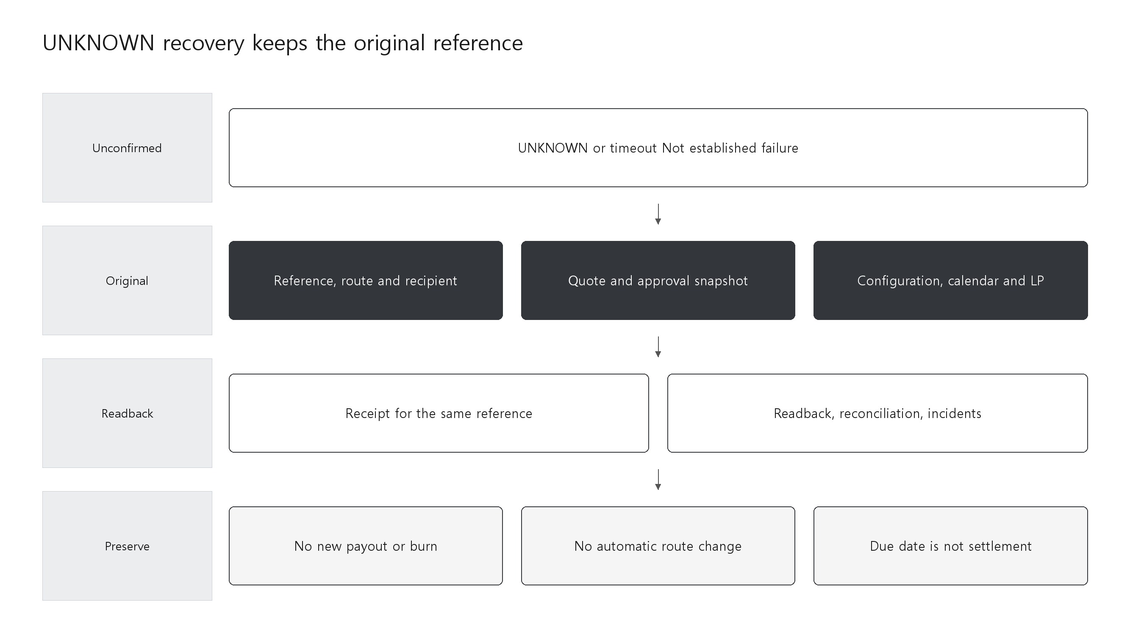
Editable diagrams
UNKNOWN recovery uses the original reference, route, recipient, quote, approval and configuration snapshot. It creates no new payout or burn and no automatic route change. A due date does not confirm settlement.

01 MIZAN financial operations
Role · Administrator
Application screen direction · Presentation opening screen.
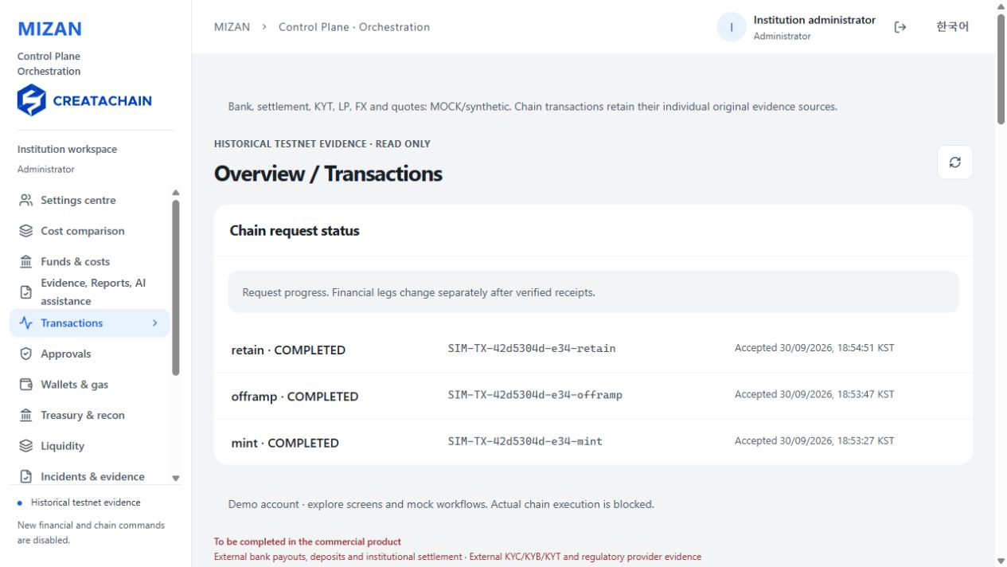
Saved screen 01 · 2026-10-03 · REVIEW
Read aloud
MIZAN connects payment requests, approvals, payout, settlement and reconciliation through the evidence of one transaction. Each stage shows who is responsible and what remains to be done.
This presentation uses saved REVIEW screens. Historical testnet evidence is distinct from MOCK bank, settlement, KYT, LP and FX data. No real financial execution takes place.
If the screen differs · Choose the relevant workflow from the scene list.

02 Roles and responsibilities
Role · Super administrator
Application screen direction · Sign in as Super administrator and open Accounts & access.
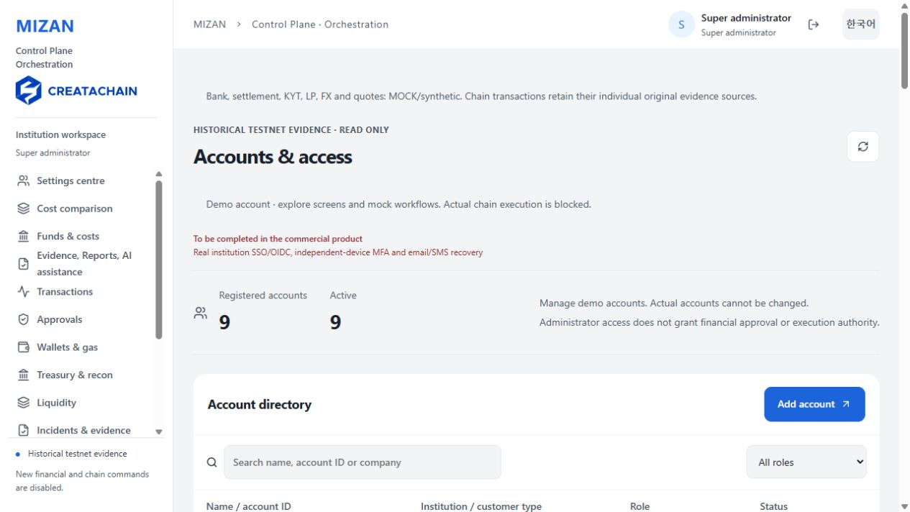
Saved screen 02 · 2026-10-02 · REVIEW
Read aloud
Each account has an assigned role and scope. Requesters prepare transactions, approvers review the conditions, and operators manage execution within the approved authority.
A super administrator cannot arbitrarily replace financial approval. The server checks institution, company, customer membership and current permissions.
If the screen differs · Check the current account role and membership.

03 Transaction states
Role · Administrator
Application screen direction · Open Transactions.
Saved screen 03 · 2026-10-03 · REVIEW
Read aloud
The transaction list separates USDC processing, customer payout, institution settlement, LP repayment and reconciliation. Completion of payout can still leave work at other stages.
Compare the representative transaction with the partial repayment case. Completed stages and remaining obligations stay connected to the original transaction reference.
If the screen differs · Read the stage status columns in order.

04 Following a transaction
Role · Administrator
Application screen direction · Open Async Recovery Merchant and select the journey tab.
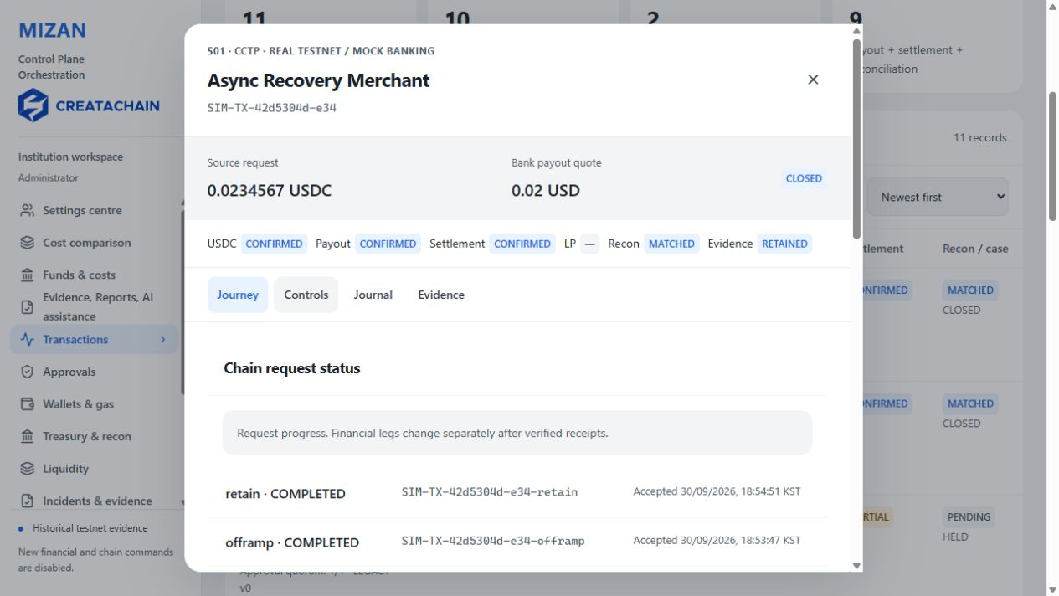
Saved screen 04 · 2026-10-03 · REVIEW
Read aloud
The detail view separates the requested amount, processed USDC and bank payout amount. Values in different assets and currencies are not combined into one amount.
Burn, attestation, mint, FX, payout and settlement retain their original references and receipts. Command acceptance and confirmation of the result remain separate states.
If the screen differs · Read the stage cards inside the detail view.

05 Approval conditions and residuals
Role · Administrator
Application screen direction · In transaction details open Controls and scroll inside the dialog.
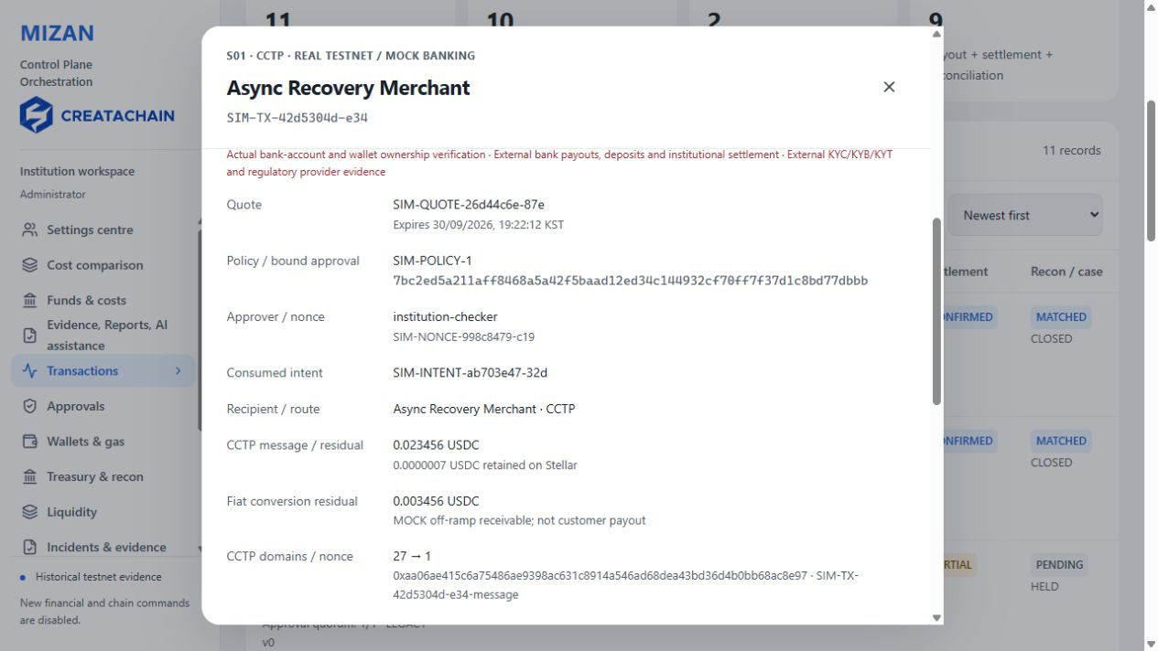
Saved screen 05 · 2026-10-03 · REVIEW
Read aloud
Approval binds the amount, recipient, route, quote and applicable configuration. Changed conditions cannot reuse the original approval.
Small residual amounts are preserved separately from principal. Zenith anchors approval, policy and evidence hashes. Catena is the execution layer and is distinct from official Circle CCTP domains.
If the screen differs · Compare the original quote and residual cards.

06 Journal and reserved funds
Role · Administrator
Application screen direction · Open Journal in the transaction dialog.
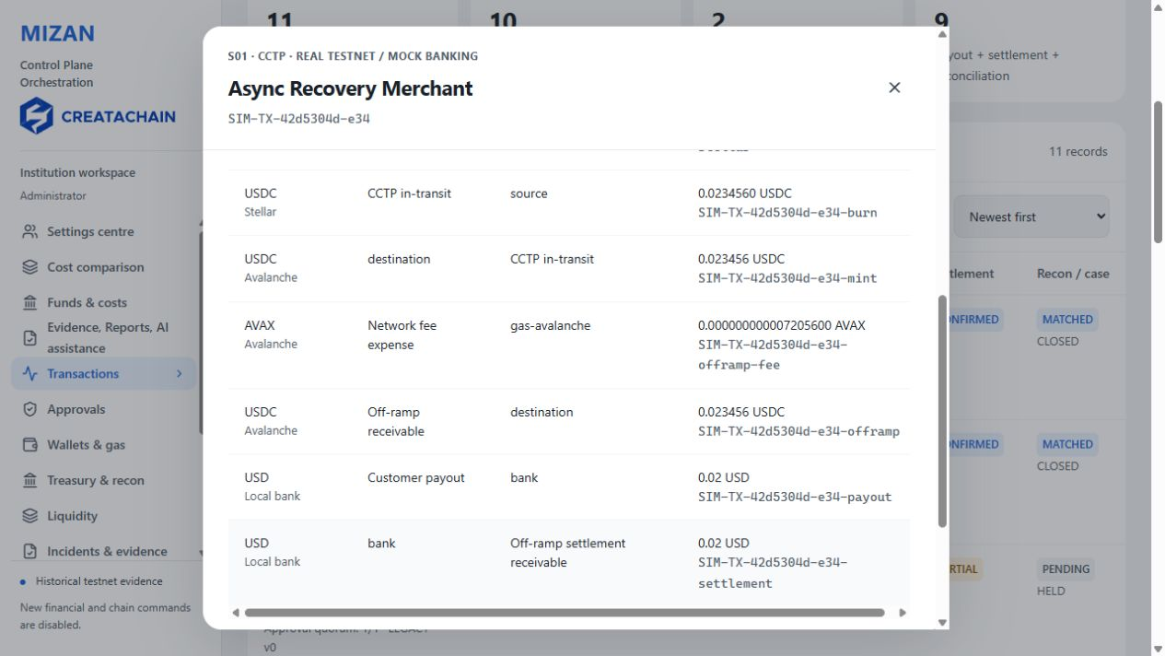
Saved screen 06 · 2026-10-03 · REVIEW
Read aloud
The journal connects movements in each asset and currency to the original transaction. Repeating a request must not record the same financial event twice.
Reserved funds cannot be used by another request. An unconfirmed transaction retains its reservation until the result of the original operation is established.
If the screen differs · Read the asset and original reference first.

07 Transaction evidence
Role · Administrator
Application screen direction · Open Evidence and inspect the original receipts.
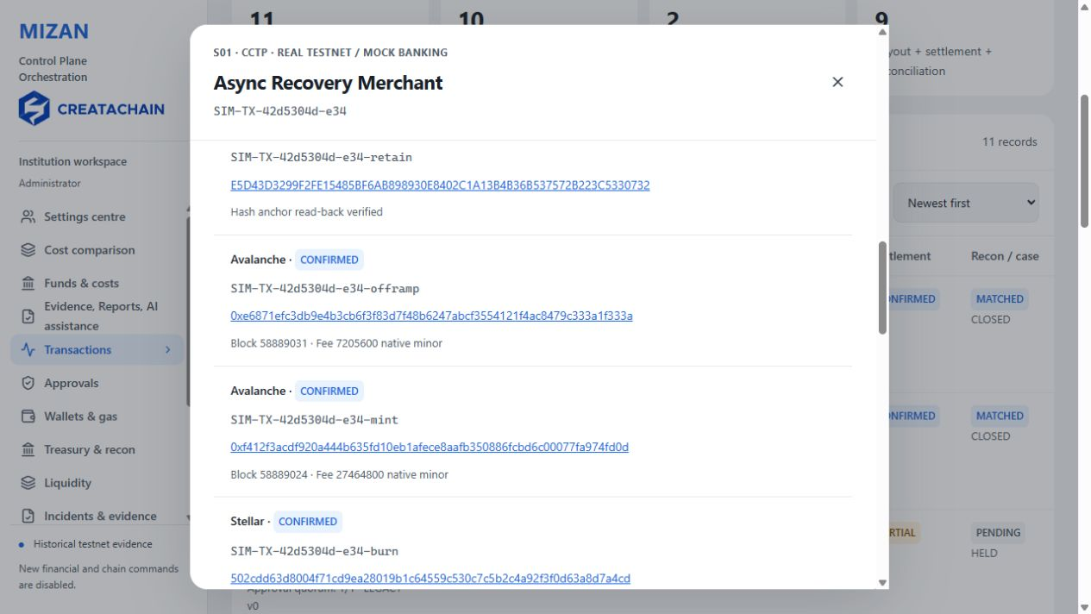
Saved screen 07 · 2026-10-03 · REVIEW
Read aloud
Submissions, receipts and readback observations stay connected to the transaction. Failed steps and later processing remain visible in the evidence trail.
Check the transaction hash, network and observation time. Historical testnet evidence and MOCK bank data retain their source labels. A hash anchor alone does not confirm financial settlement.
If the screen differs · Read the original receipt and observation time.

08 LP debt after payout
Role · Administrator
Application screen direction · Close the dialog and open Cedar LP Partial.
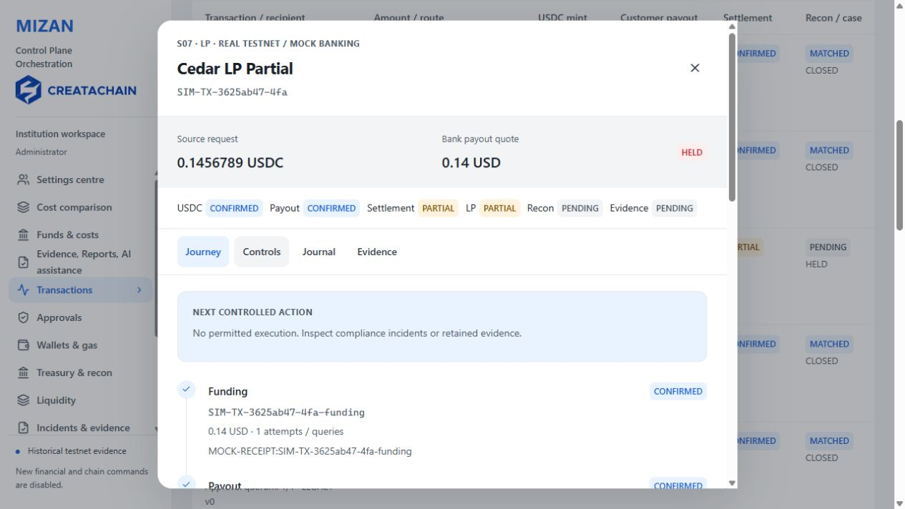
Saved screen 08 · 2026-10-03 · REVIEW
Read aloud
The partial repayment case shows customer payout completed while institution settlement and LP debt remain open. Payment to a customer and obligations to a funding provider are separate.
Read principal, period cost, repayment allocation and outstanding debt. Duplicate and excess repayments are blocked. LP funds and agreement responsibility in this case are MOCK and unconfirmed.
If the screen differs · Compare payout, settlement and outstanding debt.

09 Comparing route costs
Role · Administrator
Application screen direction · Open Total cost comparison.
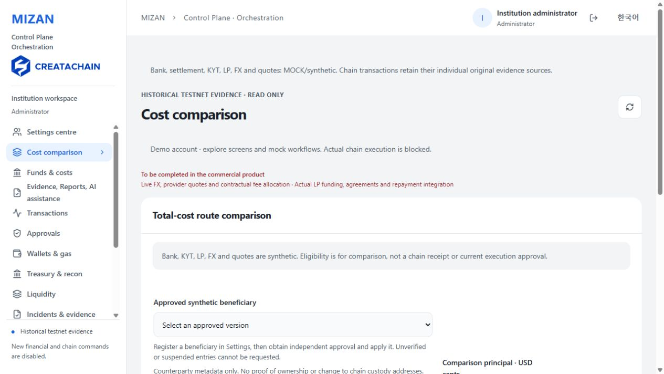
Saved screen 09 · 2026-10-03 · REVIEW
Read aloud
Route selection considers fees, FX, gas and quotation validity together. A lower cost does not permit execution when policy or approval conditions block the route.
Quotes distinguish actual evidence, MOCK and synthetic sources. A new price cannot overwrite the approved quote, and principal is not reported as revenue or profit.
If the screen differs · Check each cost currency and quotation time.

10 Quoted and observed costs
Role · Administrator
Application screen direction · Open Funds & costs and locate original quote and actual receipt costs.
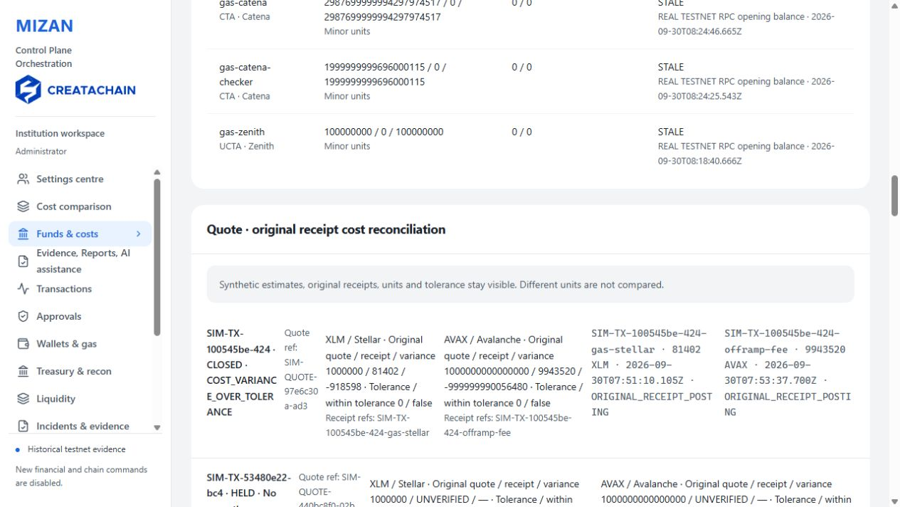
Saved screen 10 · 2026-10-03 · REVIEW
Read aloud
Quoted costs and costs observed in receipts are retained side by side. A difference beyond tolerance becomes a reconciliation issue for review.
Adjustment reasons, original cost references and allocations require independent approval. Late receipts retain the original transaction reference. A local adjustment record does not establish actual financial posting.
If the screen differs · Compare the original quote with receipt costs.

11 Cost adjustment approval
Role · Administrator
Application screen direction · In Funds & costs locate Cost adjustment approval.
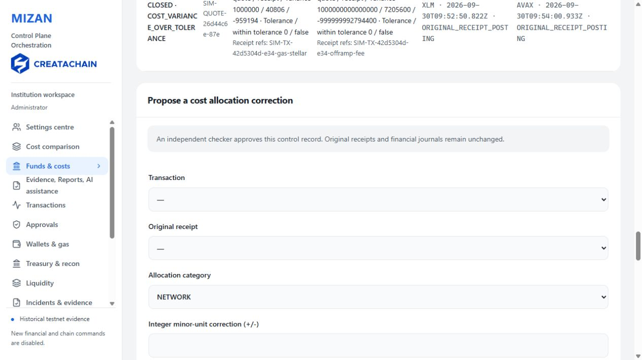
Saved screen 11 · 2026-10-03 · REVIEW
Read aloud
An adjustment binds the transaction, original receipt, adjustment amount and allocation accounts. Requesters and approvers remain separate under the business policy and validity period.
Original receipts and existing journals are preserved. This view records local allocation controls; it does not reclassify principal as cost or revenue or establish actual financial execution.
If the screen differs · Read the reason and independent approval requirements.

12 Daily close and open items
Role · Administrator
Application screen direction · In Funds & costs locate the Daily close report.
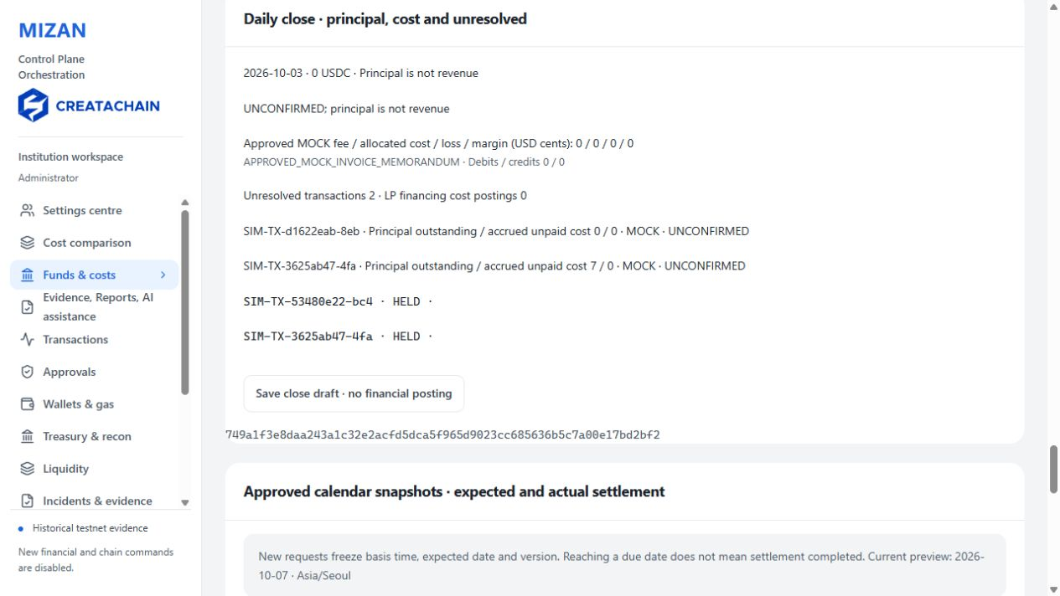
Saved screen 12 · 2026-10-03 · REVIEW
Read aloud
Closing reports separate principal movements, fees, observed costs and unresolved items for the selected period. Period totals and cumulative transaction history remain distinct.
Outstanding LP debt and late receipts link back to the original transaction and closing difference. A MOCK invoice without contract and collection evidence is not recognised commercial revenue.
If the screen differs · Check the reporting period and unresolved items.

13 Settlement calendar
Role · Administrator
Application screen direction · Open Settings centre, choose Settlement calendar · D16 and inspect its fields.
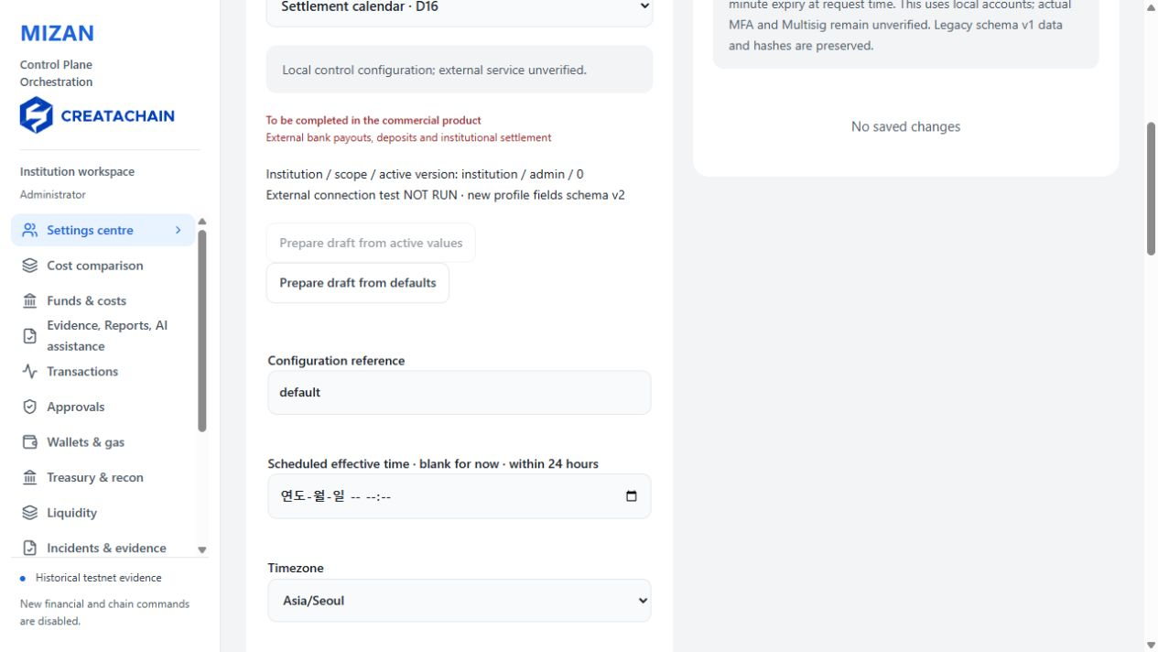
Saved screen 13 · 2026-10-03 · REVIEW
Read aloud
The calendar applies time zones, business days, holidays, cut off times and settlement delays. Requests after cut off or on a holiday use the next eligible business day.
Daylight saving rules also apply to overseas time zones. The scheduled date is a plan; reaching it does not confirm settlement without receipt and reconciliation evidence.
If the screen differs · Read the time zone, cut off and holiday rules.

14 Fixed transaction schedules
Role · Administrator
Application screen direction · In Funds & costs locate Approved settlement schedules.
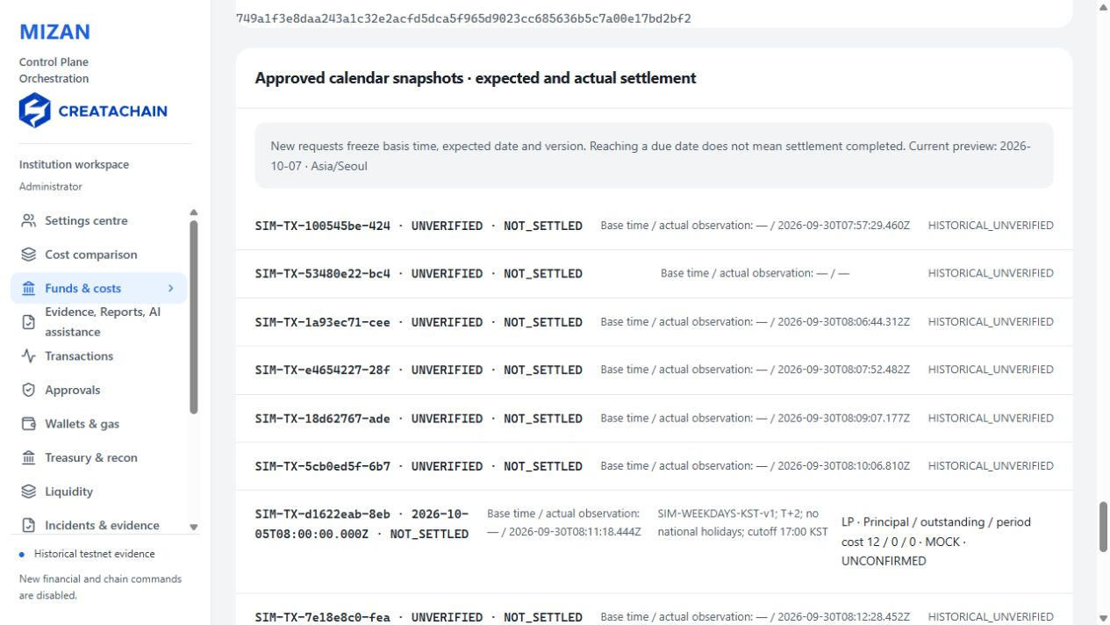
Saved screen 14 · 2026-10-03 · REVIEW
Read aloud
New transactions bind the calendar ID, version, hash, reference time and due date to the quote and approval. Later calendar changes preserve existing transaction schedules.
The new version applies to subsequent requests. Missing snapshots are not retroactively attached to historical records, and recovery uses the original approval and schedule.
If the screen differs · Check the applicable version and reference time.

15 LP agreements and period costs
Role · Administrator
Application screen direction · In Settings centre choose LP agreement · D17.
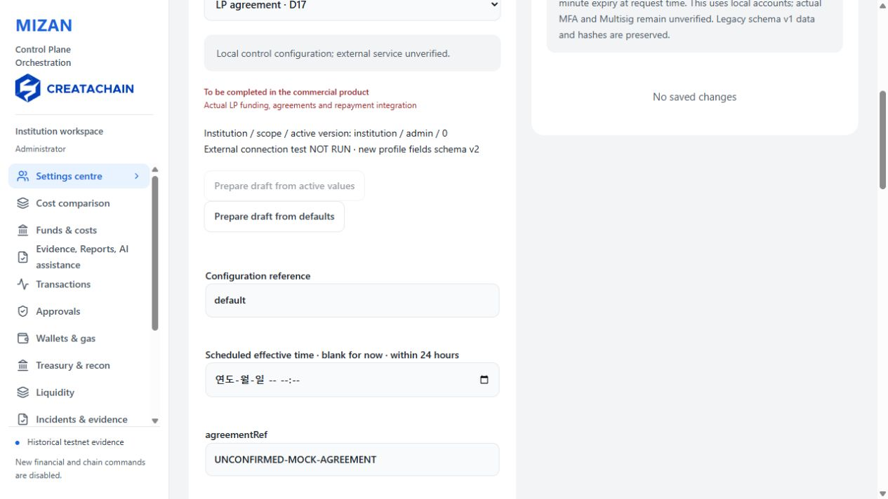
Saved screen 15 · 2026-10-03 · REVIEW
Read aloud
LP agreements connect the counterparty, principal limit, validity period and cost calculation basis. Each transaction retains its agreement version and cost period.
Principal, cost, partial repayment and outstanding debt use integer minor units. An UNCONFIRMED or MOCK agreement is not a signed commercial contract or an agreed allocation of losses.
If the screen differs · Read the agreement status and cost period.

16 Configuration approval
Role · Administrator
Application screen direction · Open Settings and versions.
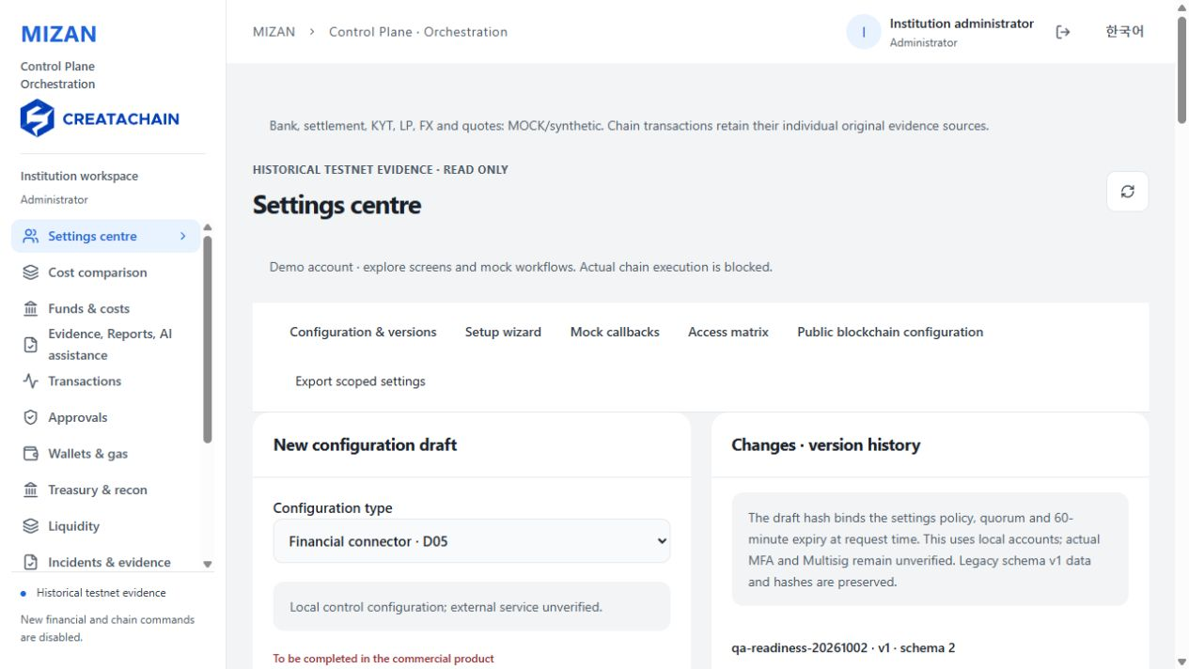
Saved screen 16 · 2026-10-03 · REVIEW
Read aloud
Settings pass through draft, validation, submission, independent approval and activation. The scope and differences from the previous version remain visible.
The submission retains its approval policy and quorum. Self approval, expired approvals and approvals from another scope are rejected. Changes apply to new requests.
If the screen differs · Distinguish draft, approved and active versions.

17 Preparing a workflow
Role · Administrator
Application screen direction · Open the Setup wizard.
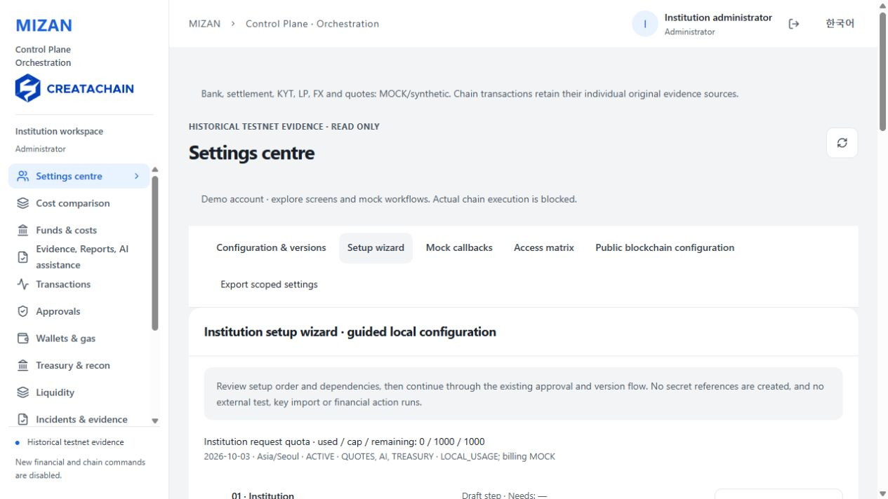
Saved screen 17 · 2026-10-03 · REVIEW
Read aloud
The setup wizard shows dependencies across institution, permissions, providers, routes, quotes and approvals. Missing prerequisites identify the next preparation task.
Local configuration and actual external integration are separate. The small red notice identifies work that needs preparation and verification in the commercial product.
If the screen differs · Check missing prerequisites and the responsible role.

18 Period and customer limits
Role · Administrator
Application screen direction · In Settings centre choose Period and customer limits · D12.
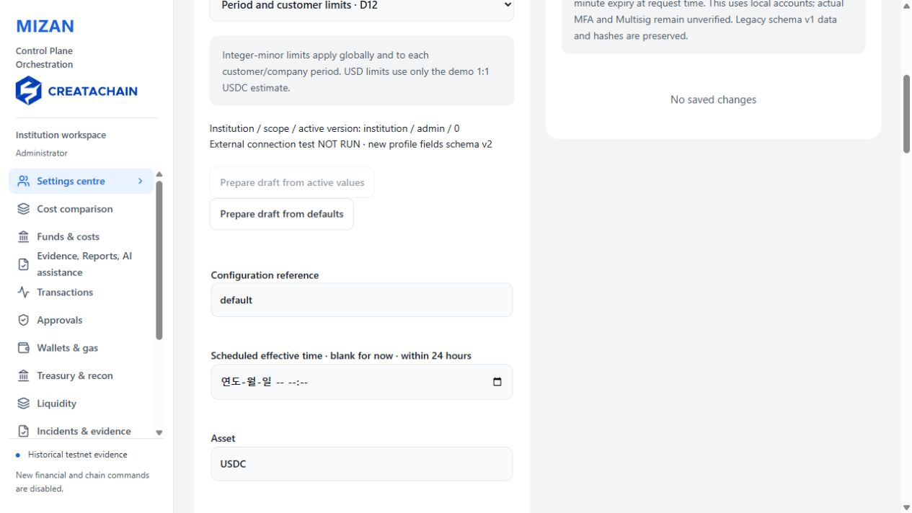
Saved screen 18 · 2026-10-03 · REVIEW
Read aloud
Limits apply to individual requests and to their period, customer, company and currency. Reserved and executed amounts are managed together.
Concurrent requests and repeated references cannot bypass limits. Reservations for unconfirmed transactions are not arbitrarily released, and limit changes require independent approval.
If the screen differs · Check period boundaries, currency and scope.

19 Bank responses and replay
Role · Administrator
Application screen direction · Open the MOCK callback panel or the Bank connector D05 settings.
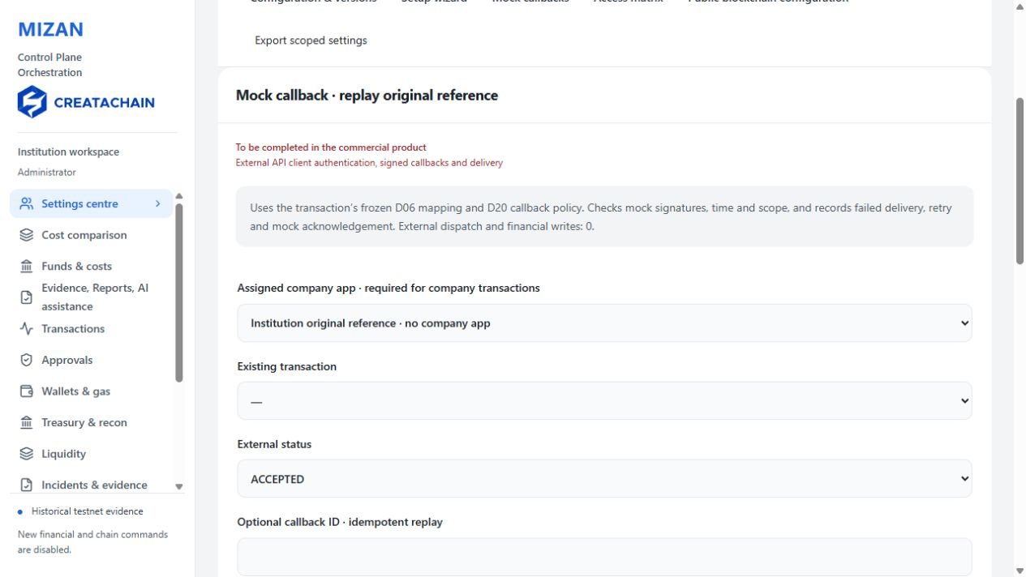
Saved screen 19 · 2026-10-03 · REVIEW
Read aloud
External bank response codes map to payout, settlement and reconciliation states while preserving the original reference. Local diagnostics cover success, unpaid results, timeouts and malformed responses.
Replaying the same response creates no new payout or duplicate journal entry. These diagnostics are MOCK and do not establish real bank authentication or live payment communication.
If the screen differs · Read the response source and observation time.

20 Request approval and execution
Role · Approval officer
Application screen direction · Sign in as Approver and open Approvals.
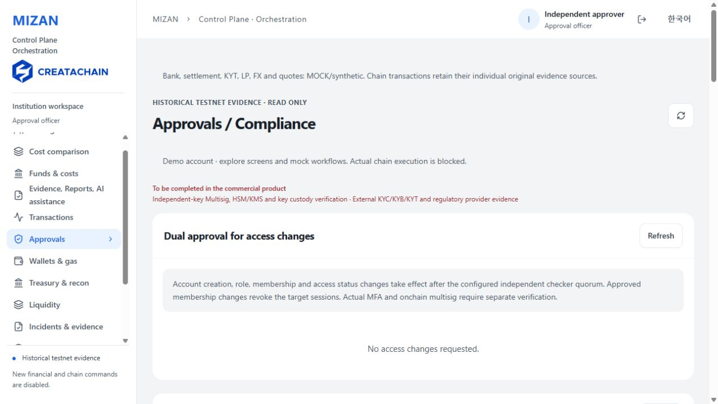
Saved screen 20 · 2026-10-03 · REVIEW
Read aloud
Requesters prepare conditions, approvers review the amount, recipient, route and policy, and operators work from the approved conditions and original reference.
A business approval quorum is separate from login MFA and cryptographic multisignature. Actual signatures using independent devices and keys require separate verification.
If the screen differs · Check each role and approval scope.

21 Compliance and risk holds
Role · Compliance officer
Application screen direction · Sign in as Compliance officer and open Incidents & evidence.
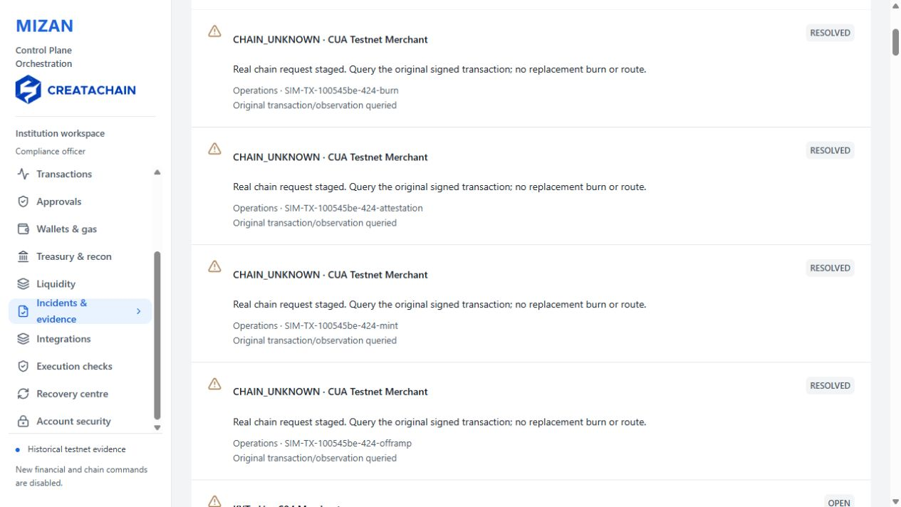
Saved screen 21 · 2026-10-03 · REVIEW
Read aloud
Compliance officers manage risk and hold reasons. Auditors review transactions, approvals, journals and evidence. High risk transactions can be held before burn, mint or payout.
Closing an incident or receiving an AI explanation does not unlock the transaction. Required authority and approval remain necessary, and actual KYT evidence stays distinct from MOCK results.
If the screen differs · Read the hold reason and unexecuted stages.

22 Personal customer scope
Role · Personal customer
Application screen direction · Sign in as Personal customer and open My transfers or Transfer request.
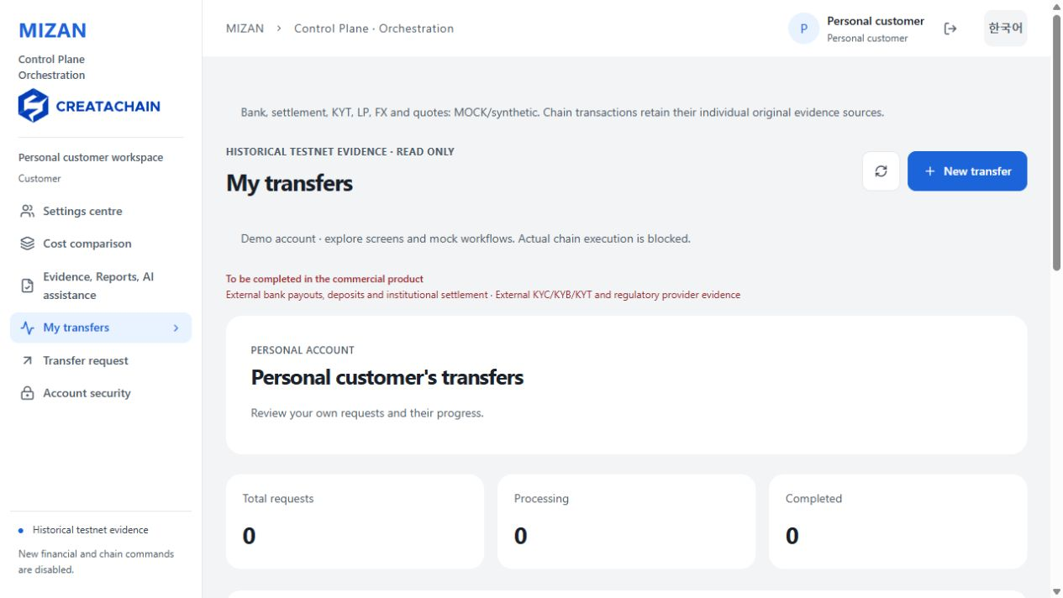
Saved screen 22 · 2026-10-02 · REVIEW
Read aloud
A personal customer sees only their assigned transactions and evidence. Institution wide staff records are not exposed as the customer's transactions.
Requests bind the signed in customer, approved recipient, quote and limits. Changing the language or transaction reference cannot grant another customer's permissions.
If the screen differs · Check the current customer's assigned scope.

23 Business customer scope
Role · Business customer
Application screen direction · Sign in as Business customer and open My transfers.
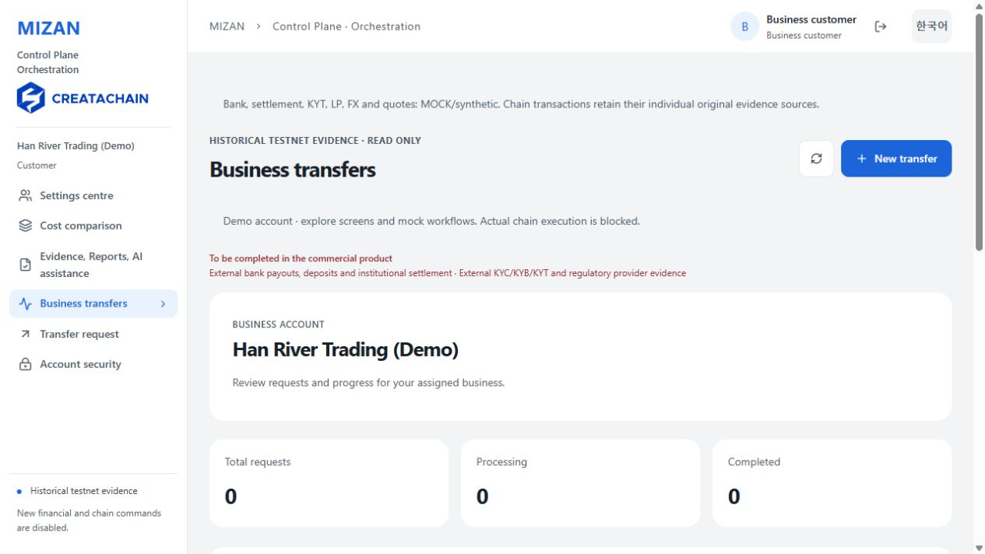
Saved screen 23 · 2026-10-02 · REVIEW
Read aloud
Business customers see transactions linked to their institution, company and customer membership. Access policies and business API settings follow that scope.
Membership changes, expiry, suspension and revocation apply to new requests while preserving original membership and evidence for existing transactions. Actual partner authentication requires separate integration verification.
If the screen differs · Check company membership and access status.

24 AI usage policy
Role · Administrator
Application screen direction · In Settings centre choose AI policy · D30.
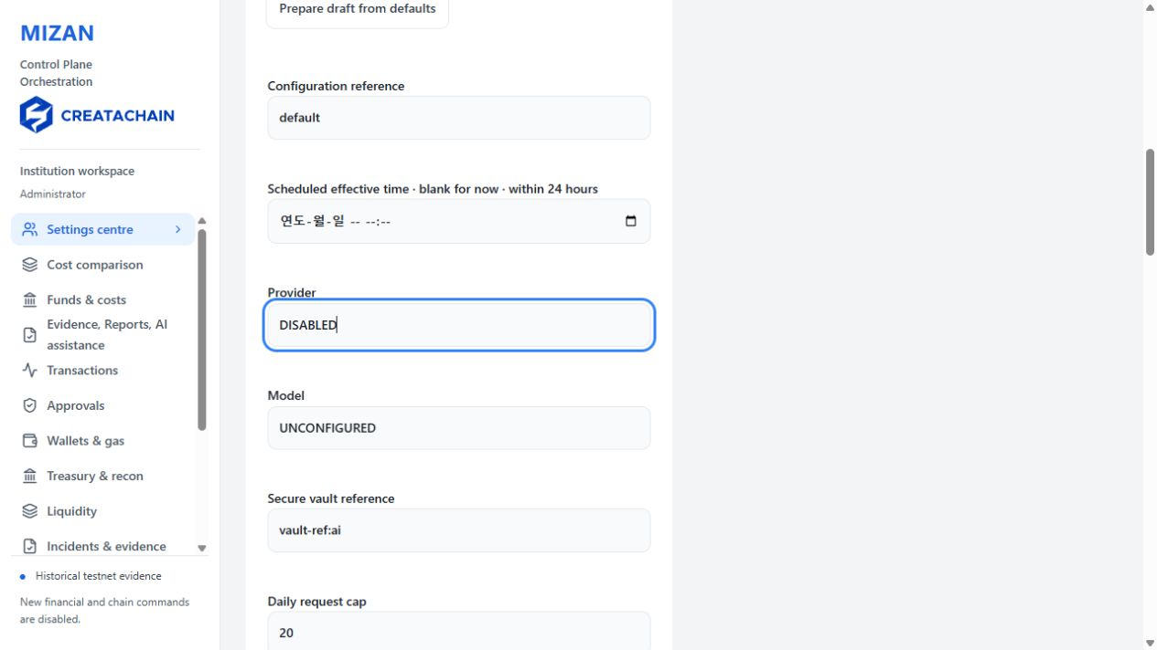
Saved screen 24 · 2026-10-03 · REVIEW
Read aloud
AI supports evidence explanation, search and drafting. It has no authority to approve, sign, pay, burn or unlock. Allowed material and usage limits are governed by policy.
The actual model is currently DISABLED and UNCONFIGURED, with external transmission blocked. Registering a key reference does not activate it.
If the screen differs · Read D30 material rules, usage limits and disabled status.

25 Evidence and report drafts
Role · Administrator
Application screen direction · Open Evidence, Reports, AI assistance and inspect the stored local draft screen.
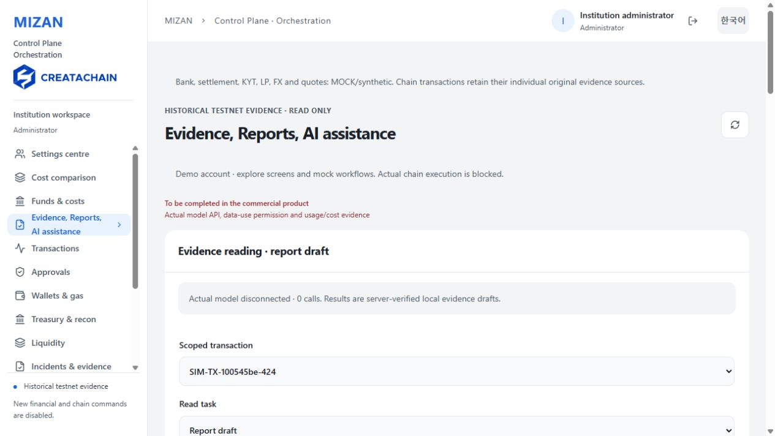
Saved screen 25 · 2026-10-02 · REVIEW
Read aloud
Evidence, Reports, AI assistance uses allowed documents and operational evidence for explanation, search and draft preparation. Results retain their original source references.
The displayed result is a local evidence result created without an actual model. A draft is not a final report; its content snapshot and business policy require independent approval.
If the screen differs · Check original sources and the draft approval status.

26 Recovering an unconfirmed transaction
Role · Operations officer
Application screen direction · Sign in as Operator and open Recovery centre.
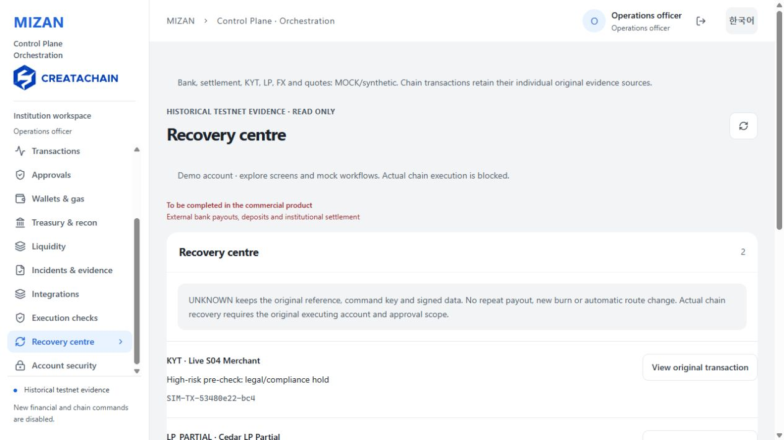
Saved screen 26 · 2026-10-02 · REVIEW
Read aloud
UNKNOWN means the result is unconfirmed rather than a confirmed failure. A payment may have occurred during a timeout, so recovery creates no new payout or burn.
Use the original reference, route, recipient, quote, approval and configuration snapshot to locate receipts. Later settings cannot replace those conditions, trigger an automatic route change or turn uncertainty into MOCK success.
If the screen differs · Read original receipts and readback history.

27 Accounts and access
Role · Super administrator
Application screen direction · Super administrator → Accounts & access.
Saved screen 27 · 2026-10-02 · REVIEW
Read aloud
Account roles, membership and access status are managed together. Invitations, expiry, suspension and revocation remain connected to the assigned responsibilities.
A change of operator preserves original transaction approvals and evidence. Account administration does not automatically grant financial approval or execution authority.
If the screen differs · Check account status, membership and responsibilities.

28 Workflow summary
Role · Keep the current account
Application screen direction · Summarise the workflow.
Saved screen 28 · 2026-10-03 · REVIEW
Read aloud
MIZAN separates request, approval and execution while retaining transaction conditions and evidence throughout the workflow. Payout, settlement, LP debt, costs and closing are reviewed independently to manage remaining work.
These are REVIEW presentation screens. Actual financial integration and independent device authentication require separate verification. MOCK data and historical testnet evidence retain their sources.
If the screen differs · Summarise transaction states, original approvals and open items.

Presenter questions and answers
Does completed payout mean the transaction is finished?
Payout, institution settlement, LP repayment and reconciliation are independent. Review remaining obligations.
Can approval be reused after changing a recipient?
Approval binds the recipient, amount, route, quote and configuration. Changed conditions require the appropriate new approval.
Does a due date confirm settlement?
No. The calendar calculates a schedule. Actual settlement requires its own receipt and reconciliation evidence.
What changes when a calendar is updated?
New versions apply to subsequent requests. Existing transactions retain their original schedule and approval conditions.

Presenter questions and answers 2
How are partial repayments managed?
Principal, period cost, repayment allocation and outstanding debt remain separate. Duplicate and excess repayments are rejected.
How are late receipts handled?
Late receipts retain the original transaction reference and observation time. Original quotes and closing records are preserved.
Can AI approve or pay?
AI has no approval, signing, payout, burn or unlocking authority. The actual model is currently disabled.
What does UNKNOWN recovery do?
It locates receipts using the original reference and conditions without creating another payout, burn or automatic route change.

